**GSD 6476 Transformable Design Methods**

Monday 10:30 am – 1:15 pm

Chuck Hoberman – Instructor  
Research Assistant Joonhaeng Lee

**Assignment #1: Create a design for an expanding linkage utilizing the methods in the September 1st lecture. Choose from the following options:**

***OPTION #1: Static design (Rhino-based)***

Create a design for an expanding linkage using angulated links. Start by creating control geometry based on an irregular (non-circular) polygon and fit your linkage to that geometry using the techniques starting on page 83 of the PDF version of the lecture.

Your design should associate physical link profiles with the underlying wireframe geometry. Show at least 3 positions of the linkage (closed, mid, open).

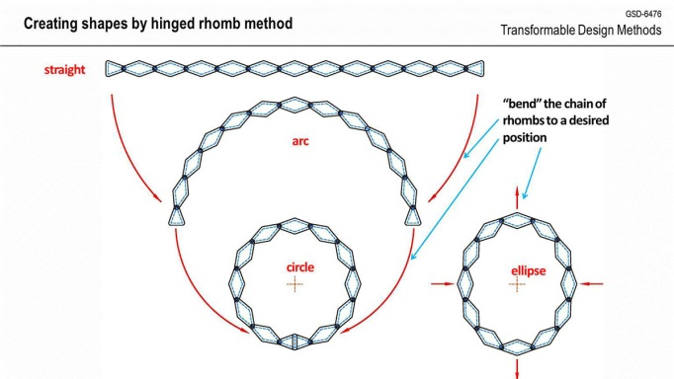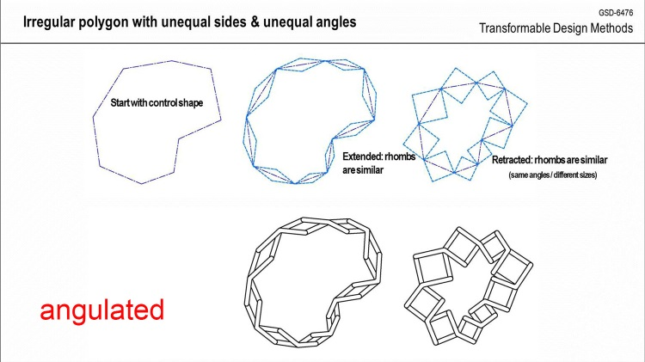

***OPTION #2: Dynamic model (Fusion 360-based)***

Following the techniques from Joon’s workshop, assemble an expanding linkage (minimum 6 links) using the part files that have been uploaded to Canvas. Demonstrate the movement of your linkage by either by screen interaction (dragging a link) or by programming it using a motion profile.

Record the interaction as a video animation.

**Submission Procedures:**

Upload a PDF showing your expanding linkage Rhino model, or a video of your fusion model (less than 15 seconds) to Course Canvas>Assignments by September 12th midnight.